Chapter 9: Sampling Distributions

Objectives: Students will:
Define a sampling distribution.
Contrast bias and variability.
Describe the sampling distribution of a sample proportion (shape, center, and spread).
Use a Normal approximation to solve probability problems involving the sampling distribution of a sample proportion.
Describe the sampling distribution of a sample mean.
State the central limit theorem.
Solve probability problems involving the sampling distribution of a sample mean.

AP Outline Fit:
III. Anticipating Patterns: Exploring random phenomena using probability and simulation (20%–30%)
D. Sampling distributions
1. Sampling distribution of a sample proportion
2. Sampling distribution of a sample mean
3. Central Limit Theorem
6. Simulation of sampling distributions

What you will learn:

- Sampling Distributions
  - Identify parameters and statistics in a sample or experiment.
  - Recognize the fact of sampling variability: a statistic will take different values when you repeat a sample or experiment.
  - Interpret a sampling distribution as describing the values taken by a statistic in all possible repetitions of a sample or experiment under the same conditions.
  - Describe the bias and variability of a statistic in terms of the mean and spread of its sampling distribution.
  - Understand that the variability of a statistic is controlled by the size of the sample. Statistics from larger samples are less variable.
- Sample Proportions
  - Recognize when a problem involves a sample proportion .
  - Find the mean and standard deviation of the sampling distribution of a sample proportion for an SRS of size n from a population having population proportion p.
  - Know that the standard deviation (spread) of the sampling distribution of gets smaller at the rate as the sample size n gets larger.
  - Recognize when you can use the Normal approximation to the sampling distribution of . Use the Normal approximation to calculate probabilities that concern .
- Sample Means
  - Recognize when a problem involves the mean of a sample.
  - Find the mean and standard deviation of the sampling distribution of a sample mean from an SRS of size n when the mean µ and standard deviation σ of the population are known.
  - Know that the standard deviation (spread) of the sampling distribution of gets smaller at the rate as the sample size n gets larger.
  - Understand that has approximately a Normal distribution when the sample is large (central limit theorem). Use this Normal distribution to calculate probabilities involving .

Section 9.1: Sampling Distributions

Knowledge Objectives: Students will:
Compare and contrast parameter and statistic.
Explain what is meant by sampling variability.
Define the sampling distribution of a statistic.
Define an unbiased statistic and an unbiased estimator.
Describe what is meant by the variability of a statistic.

Construction Objectives: Students will be able to:
Explain how to describe a sampling distribution.
Explain how bias and variability are related to estimating with a sample.

Vocabulary:
Parameter – a number that describes the population
Statistic – a number that can be computed from the sample data without making use of any unknown parameters
μ (Greek letter mu) – symbol used for the mean of a population
x̄ (x-bar) – symbol used for the mean of the sample
Sampling Distribution (of a statistic) – the distribution of values taken by the statistic in all possible samples of the same size from the same population
Bias – the level of trustworthiness of a statistic
Unbiased Statistic – a statistic whose sampling distribution mean is equal to the true value of the parameter being estimated; also known as an unbiased estimator
Variability (of a statistic) – a description of the spread of the statistic’s sampling distribution

Key Concepts:

- Population Parameters
  - Usually unknown and are estimated by sample statistics using techniques we will learn
  - Mean: μ
  - Standard Deviation: σ
  - Proportion: p
- Sample Statistics
  - Used to estimate population parameters
  - Mean: x̄
  - Standard Deviation: s
  - Proportion: p̂

Example 1: Upon entry to an airport’s customs area each passenger presses a button and either a green arrow comes on (directing the passenger on through) or a red arrow comes on (directing them to a customs agent) and they have the bags searched. Homeland Security sets the “search” parameter at 30%.
- What type of probability distribution applies here?

- What are the mean and standard deviation of this distribution?

- Each of you represents a day, 8 in total, that we are going to simulate a simple random sampling of 100 passengers passing through the airport. We want to know what your individual average proportion of those who got the green arrow. This we will refer to as p-hat or p̂. To do this we will use our calculator.

- We can also use our calculator to simulate this and just get the total number, which represents p-hat or p̂.

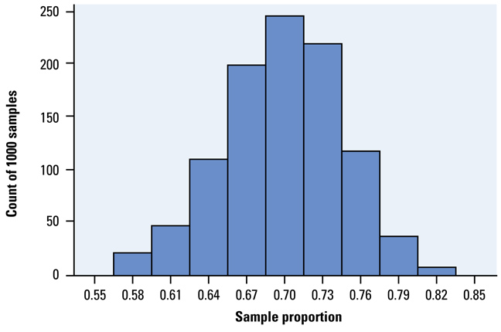
- Describe the distribution below

Example 2: Which of these sampling distributions displays large or small bias and large or small variability?

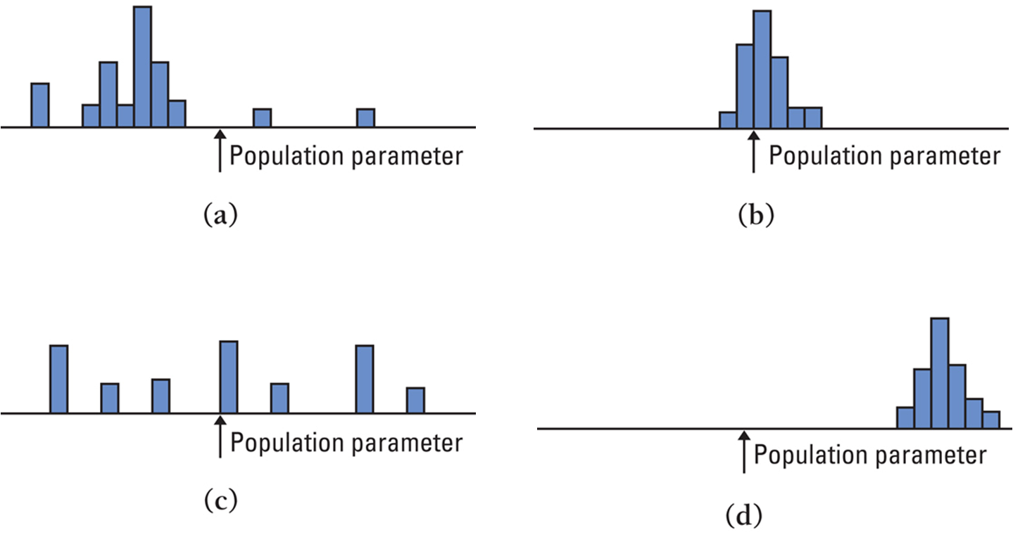

Homework:
Day 1: pg 568-70: 9.1, 9.2, 9.4 (for turn-in)
Day 2: pg 578-80: 9.9-13, 9-16 (16d for turn-in)
Section 9.2: Sample Proportions

Knowledge Objectives: Students will:
Identify the “rule of thumb” that justifies the use of the recipe for the standard deviation of .
Identify the conditions necessary to use a Normal approximation to the sampling distribution of .

Construction Objectives: Students will be able to:
Describe the sampling distribution of a sample proportion. (Remember: “describe” means tell about shape, center, and spread.)
Compute the mean and standard deviation for the sampling distribution of.
Use a Normal approximation to the sampling distribution of to solve probability problems involving.

Vocabulary:
Sample proportion – p-hat is x / n ; where x is the number of individuals in the sample with the specified characteristic (x can be thought of as the number of successes in n trials of a binomial experiment). The sample proportion is a statistic that estimates the population portion, p.

Key Concepts:

Conclusions regarding the distribution of the sample proportion:
Shape: as the size of the sample, n, increases, the shape of the distribution of the sample proportion becomes approximately normal
Center: the mean of the distribution of the sample proportion equals the population proportion, p.
Spread: standard deviation of the distribution of the sample proportion decreases as the sample size, n, increases

Sampling Distribution of p-hat
For a simple random sample of size n such that n ≤ 0.10N (sample size is ≤ 10% of the population size)
The shape of the sampling distribution of p-hat is approximately normal provided
np ≥ 10 and n(1 – p) ≥ 10
The mean of the sampling distribution of p-hat is μ p-hat = p
The standard deviation of the sampling distribution of p-hat is σ = √(p(1 – p)/n)

Example 1: Assume that 80% of the people taking aerobics classes are female and a simple random sample of n = 100 students is taken. What is the probability that at most 75% of the sample students are female?

Example 2: Assume that 80% of the people taking aerobics classes are female and a simple random sample of n = 100 students is taken. If the sample had exactly 90 female students, would that be unusual?

Example 3: According to the National Center for Health Statistics, 15% of all Americans have hearing trouble. In a random sample of 120 Americans, what is the probability at least 18% have hearing trouble?

Example 4: According to the National Center for Health Statistics, 15% of all Americans have hearing trouble. Would it be unusual if the sample above had exactly 10 having hearing trouble?

Example 5: We can check for undercoverage or nonresponse by comparing the sample proportion to the population proportion. About 11% of American adults are black. The sample proportion in a national sample was 9.2%. Were blacks underrepresented in the survey?

Summary: The sample proportion, p-hat, is a random variable
- If the sample size n is sufficiently large and the population proportion p isn’t close to either 0 or 1, then this distribution is approximately normal
- The mean of the sampling distribution is equal to the population proportion p
- The standard deviation of the sampling distribution is equal to √p(1-p)/n

Homework:
Day 1: pg 588-9; 9.19-21, 24
Day 2: pg 589-91; 9.25-30
Section 9.3: Sample Means

Knowledge Objectives: Students will:
State the central limit theorem.

Construction Objectives: Students will be able to:
Given the mean and standard deviation of a population, calculate the mean and standard deviation for the sampling distribution of a sample mean.
Identify the shape of the sampling distribution of a sample mean drawn from a population that has a Normal distribution.
Use the central limit theorem to solve probability problems for the sampling distribution of a sample mean.

Vocabulary:
Central Limit Theorem – the larger the sample size, the closer the sampling distribution for the sample mean from any underlying distribution approaches a Normal distribution
Standard error of the mean – standard deviation of the sampling distribution of x-bar

Key Concepts:

Conclusions regarding the sampling distribution of X-bar:
Shape: normally distributed
Center: mean equal to the mean of the population
Spread: standard deviation less than the standard deviation of the population

Mean and Standard Deviation of the Sampling Distribution of x-bar
Suppose that a simple random sample of size n is drawn from a large population (sample less than 5% of population) with mean μ and a standard deviation σ. The sampling distribution of x-bar will have a mean
μ,_{x-bar} = μ and standard deviation σ_{x-bar} = σ/√n. The standard deviation of the sampling distribution of x-bar is called the standard error of the mean and is denoted by σ_{x-bar}.

The shape of the sampling distribution of x-bar if X is normal
If a random variable X is normally distributed, the distribution of the sample mean, x-bar, is normally distributed.

Central Limit Theorem
Regardless of the shape of the population, the sampling distribution of x-bar becomes approximately normal as the sample size n increases. (Caution: only applies to shape and not to the mean or standard deviation)

From Sullivan: “With that said, so that we err on the side of caution, we will say that the distribution of the sample mean is approximately normal provided that the sample size is greater than or equal to 30, if the distribution of the population is unknown or not normal.”

Example 1: The height of all 3-year-old females is approximately normally distributed with μ = 38.72 inches and σ = 3.17 inches. Compute the probability that a simple random sample of size n = 10 results in a sample mean greater than 40 inches.

Example 2: We’ve been told that the average weight of giraffes is 2400 pounds with a standard deviation of 300 pounds. We’ve measured 50 giraffes and found that the sample mean was 2600 pounds. Is our data consistent with what we’ve been told?

Example 3: Young women’s height is distributed as a N(64.5, 2.5), What is the probability that a randomly selected young woman is taller than 66.5 inches?

Example 4: Young women’s height is distributed as a N(64.5, 2.5), What is the probability that an SRS of 10 young women is greater than 66.5 inches?

Example 5: The time a technician requires to perform preventive maintenance on an air conditioning unit is governed by the exponential distribution (similar to curve a from “in Action” slide). The mean time is μ = 1 hour and σ = 1 hour. Your company has a contract to maintain 70 of these units in an apartment building. In budgeting your technician’s time should you allow an average of 1.1 hours or 1.25 hours for each unit?

Summary: The sample mean is a random variable with a distribution called the sampling distribution
- If the sample size n is sufficiently large (30 or more is a good rule of thumb), then this distribution is approximately normal
- The mean of the sampling distribution is equal to the mean of the population
- The standard deviation of the sampling distribution is equal to σ / √n

Homework:
Day 1: pg 595-6; 9.31-4
Day 2: pg 601-4; 9.35, 36, 38, 42-44
Chapter 9: Review

Objectives: Students will be able to:
Summarize the chapter
- Define a sampling distribution
- Contrast bias and variability
- Describe the sampling distribution of a sample proportion (shape, center, and spread)
- Use a Normal approximation to solve probability problems involving the sampling distribution of a sample proportion
- Describe the sampling distribution of a sample mean
- State the central limit theorem
- Solve probability problems involving the sampling distribution of a sample mean
Define the vocabulary used
Know and be able to discuss all sectional knowledge objectives
Complete all sectional construction objectives
Successfully answer any of the review exercises

Vocabulary: None new

Homework: pg 607 – 609; 9.47, 49-53, 56, 58

